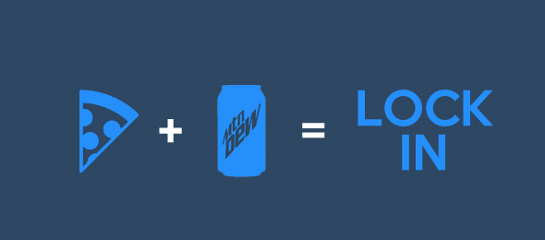

When: Friday, March 30th from 4:00pm till Saturday 8am.

What: Activities will include a trip to Richmond’s new Boomerang Air Sports, dinner, worship with the Effort band, guest speaker, and night full of games, food, and fun.

Cost: $45 will cover the full night of activities and meals. If you’re only able to attend part of the night you can do that as well. $35 for the first half or $20 for the second half.

If your student would like to do the high ropes zip line at Boomerang, please include an additional $7. We know not all students will want to do this, just let us know if your student is a risk taker!

Please fill out and return the attached consent form (if you have not previously) by March 25th with your payment to reserve your spot. You will also need to complete the online waiver for Boomerang in order for your child to participate. https://www.boomerangairsports.com/sign-waiver. Please include the Jump ID number(43373) when you sign your waiver.

EBC Consent Form
Student:
Name: Date of Birth: Age: Gender: M F
Address: State: Zip: .

Parent/Guardian (if under 18 years of age):

Name: Phone #: .
Name: Phone #: .

Health/Medical Info:

Health/Medical Problems: .
Drug/Food Allergies: .
Last Tetanus: Regular Medications: .
Activity Restrictions: .
Special Diet Needs: .
Family Doctor: Phone #: .
Insurance Name: Phone #: .
Policy Holder: Birthdate of Policy Holder: .
Policy #: .

Effort Baptist has permission to administer:
Ibuprofen Tylenol Benadryl Neosporin

Emergency Contact:
Name: Phone #: .

Specified Consent:

By signing below, I grant permission for my child to participate in activities provided by and located at Effort Baptist. If I do not wish for my child to participate in any activity, it is my responsibility to inform a youth leader of Effort Baptist prior to my child’s arrival.

The undersigned hereby acknowledges that the program(s) in which I have enrolled my child(ren) involves physical activity and exercise that carries some inherent health risks and risks of injury and I hereby assume those risks in enrolling my child(ren) in the program. I understand that my child(ren) may be transported by bus, van or private automobile to locations off the Effort Baptist grounds as part of the program activities, and I hereby give my permission for my child(ren)’s transportation. I also grant permission for my child(ren) to receive emergency medical attention should I not be able to be contacted in a timely fashion.

I, the undersigned, do hereby consent to the use by Effort Baptist of my child’s image or voice in any video, photograph or audio tape used for fundraising, advertising, publicity, or any other purpose on behalf of Effort Baptist. I also confirm that Effort Baptist and staff are not responsible for loss or damage of any personal items brought by students. After students are registered and confirmed by deposit, there are no cancellations or refunds.

Signature: Date: .

