Creation Festival
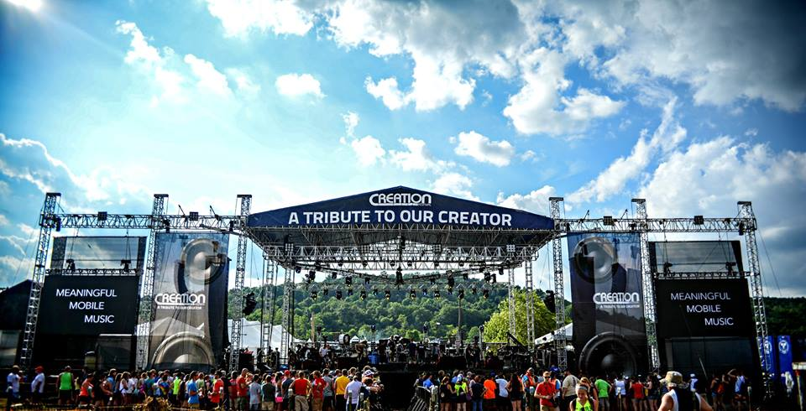
When: June 27 - July 1, We will leave at 7am on Wednesday morning and return Sunday around noon.

Where: Agape Farm, Mt. Union, PA

What: We are headed back for our fourth year of a camping experience like no other. We will join together with 50,000 people for 5 days of Christian bands, speakers and entertainment.

Ages: Open to all students entering 7th grade through graduated 12th. Students must be engaged in youth activities and have been on an overnight trip with us before.

Lodging: Students will be staying in tents at the festival. We will have gender specific tents.

Meals: We will provide breakfast, lunch, and dinner. Extra money will be required for concessions and vendors.

Cost: $200 - $100 Non refundable Deposit Due May 20th. Final Payment ($100) Due June 17th.

Questions: See Stephen or Amy Beyer or email - Stephen@effortchurch.org

