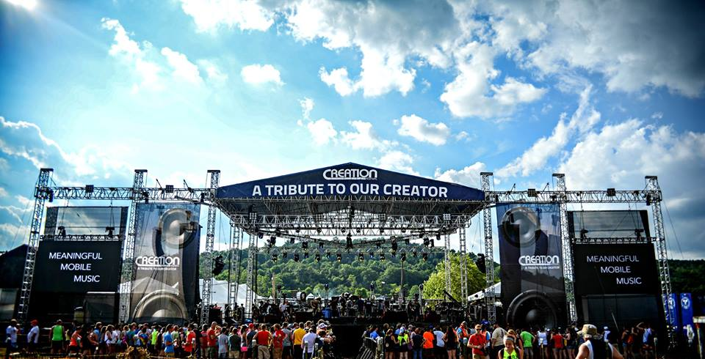

Creation Festival 2018 Packing List

Meet at the church at 7am on Wednesday, June 27th. We will be departing as soon as possible. We will return on Sunday, July 1st around 12pm.

Money your child may need

- Money for lunch as we travel on Wednesday (Fast food)
- Spending money for merchandise they may want to purchase- CD’s, t-shirts, books, etc.
- Food money for funnel cakes, snow cones, snacks throughout the day. There are food trucks throughout the campground. We will provide breakfast, lunch, and dinner each day.

Dress Code

MODESTY is the key word. Bathing suits are NOT permitted, except in the showers. Clothes must be put on over your bathing suit for the walk to and from your campsite and the showers. Tank tops are fine but no spaghetti straps. No short shorts.

Cell Phones
There will be portable towers set up at the camp for major carriers. We will do our best to keep phones charged, but electricity is not readily available. We will have a generator on the campsite, but if you have a portable battery pack you may want to bring it.
Pack List
Below is a suggested packing list. It is not meant to be comprehensive, just some helpful hints. We will be providing tents for everyone.
_____ Sunblock
_____ Insect repellent
_____ Sunglasses/hat
_____ Deodorant - please!
_____ Soap
_____ Shampoo/Conditioner
_____ Toothbrush & toothpaste
_____ Swim Suit for showering
_____ Bathroom bag-bring a small bag to carry your stuff to and from the bathroom
_____ Towel
_____ Medications
_____ Umbrella/Poncho
_____ Flashlight/Lantern
_____ Refillable Water Bottle
_____ Games-football, frisbee, cards
_____ Socks & underwear + several extra pairs extras
_____ Sneakers (if it rains it will be muddy)
_____ Flip flops or sandals
_____ Comfortable Clothes - we are outside and it will be hot
_____ Pants and sweatshirt- it may get chilly in the evenings
_____ Twin air mattress/cot. Cots fit best in the tent(you can fit your bags underneath.)
_____ Sleeping bag/blankets- it can get cold at night
_____ Pillow
_____ Blanket - to sit on during concerts/worship
_____ Folding chair for around the campsite
_____ Cell Phone/Charger/Camera- Bring at your own risk
_____ BIble
_____ Journal + pen
_____ Snacks
_____ 1 Box of cereal to share with the group
_____ 1 Case of bottled water
The key is to pack light.

